Epsom & Ewell F.C.
14
v
Sutton Common Rovers
Saturday, 3rd February 2018 – 3.00 p.m.
Good afternoon and welcome to High Road for our League match against Sutton Common Rovers. We welcome their players, supporters and officials and wish them a safe journey home, as of course we do for our own regular supporters.

Of course we also welcome back a number of our players from last season who chose to move on to our opponents during the summer. Unsurprisingly, they now sit in the top four and will present a very difficult challenge today. I must admit that I do look back at our F.A. Cup and F.A. Vase draws this season and wonder how far we would have gone with last year’s squad as they were very generous draws, looking back at how they played out. I think we’d still be in the Vase now, if I’m honest!

But that’s in the past and the club has moved on since then. It has taken time but we are now competitive again and beginning to pick up points in our attempts to avoid the drop. Our last appearance here was eleven days ago when we drew 1-1 with Abbey Rangers. Over the 90 minutes it was a very even match, but we had the better of the first half and had we scored a second or even a third goal at the time of our dominance, I don’t think they would have got back into it.

Last Saturday we travelled to Spelthorne Sports, where we picked up a creditable goalless draw, although I felt we were notably the better of the two teams in a game of few chances. We are now unbeaten in three League matches.

For those of you that have been away we have a new Caretaker Manager in charge in Neil Grant, who has stepped up from the position of Coach. We’ve found out a little about our new man and this is enclosed later in the programme. Going forward, we hope to have some articles from our new Management team for inclusion in the programme.

Please note that we have some further fixture changes to advise. Our home match with Balham has been rearranged for Tuesday 13th March, following our postponement two weeks ago, and our home match with CB Hounslow United has had to be moved from Tuesday 13th February as Chipstead required the pitch for a Surrey Senior Cup tie and will now be played on Tuesday 6th March. Coming up next for our boys is a trip to Hanworth Villa on Saturday, followed by a visit to Abbey Rangers seven days later before we return here to host Knaphill three weeks today.

Finally, thanks to all of you that have purchased our Centenary merchandise. It is available now and so if you would like to pass our Chairman your money he will let you have your special delivery!

Enjoy the game!

Rich

Don’t forget, you can now follow us on Social Media. Please see the inside cover for addresses.

Cover photos by Gemma Jarman

- Kyen Nicholas puts us ahead against Abbey Rangers on Tuesday 23rd January
- Our new Manager, Neil Grant
1
Cherry Red Records Combined Counties League
Premier Division Table 2017/18
inc Weds 31st January | P | W | D | L | F | A | Pts | GD | H | A
Westfield | 26 | 23 | 1 | 2 | 93 | 25 | 70 | +68 | 14/4 | 0-5
Bedfont Sports | 28 | 19 | 4 | 5 | 73 | 39 | 61 | +34 | 24/3 | 0-7
Walton & Hersham | 28 | 17 | 6 | 5 | 61 | 33 | 57 | +28 | 0-2 | 24/4
Sutton Common Rovers | 27 | 18 | 3 | 6 | 58 | 31 | 57 | +27 | 3/2 | 0-5
Camberley Town | 27 | 10 | 14 | 3 | 37 | 28 | 44 | +9 | 10/3 | 1-1
Knaphill | 27 | 11 | 8 | 8 | 53 | 48 | 41 | +5 | 24/2 | 2-6
Guildford City | 27 | 11 | 5 | 11 | 50 | 52 | 38 | -2 | 1-3 | 7/4
Horley Town | 24 | 11 | 5 | 8 | 39 | 46 | 38 | -7 | 2-3 | 2-3
CB Hounslow United | 25 | 11 | 4 | 10 | 40 | 32 | 37 | +8 | 6/3 | 2-4
Spelthorne Sports | 28 | 10 | 7 | 11 | 45 | 42 | 37 | +3 | 1-5 | 0-0
Hanworth Villa | 27 | 10 | 7 | 10 | 48 | 56 | 37 | -8 | 1-1 | 10/2
Balham | 22 | 9 | 5 | 8 | 40 | 37 | 32 | +3 | 13/3 | 0-4
North Greenford United | 23 | 8 | 7 | 8 | 41 | 39 | 31 | +2 | 1-2 | 17/3
Abbey Rangers | 25 | 8 | 7 | 10 | 38 | 40 | 31 | -2 | 1-1 | 17/2
Redhill | 26 | 9 | 4 | 13 | 41 | 46 | 31 | -5 | 0-5 | 0-3
Chertsey Town | 27 | 8 | 3 | 16 | 47 | 61 | 27 | -14 | 2-7 | 0-1
AFC Hayes | 24 | 7 | 5 | 12 | 35 | 47 | 26 | -12 | 28/4 | 0-2
Colliers Wood United | 25 | 6 | 4 | 15 | 42 | 51 | 22 | -9 | 30/3 | 2-5
Farnham Town | 26 | 5 | 7 | 14 | 32 | 48 | 22 | -16 | 3-0 | 0-0
Banstead Athletic | 23 | 5 | 6 | 12 | 30 | 55 | 21 | -25 | 2/4 | 1-1
Godalming Town | 26 | 4 | 6 | 16 | 27 | 58 | 18 | -31 | 0-3 | 2-1
Epsom and Ewell | 27 | 2 | 6 | 19 | 24 | 80 | 12 | -56 | X | X
1

Lucky Day? – 3rd February
Played 13 - Won 7 Drawn 2 Lost 4 - For 32 Against 21 - PPG 1.77 - Good
Our Club record against today’s opponent
Played 14 - W 9 D 3 L 2 - F 30 A 19 - PPG 2.14 - Very Good
Our Largest wins and losses against today’s opponent
30th November 2013 - W 4-0 - Combined Counties League (H)
21st August 2017 - L 0-5 - Combined Counties League (A)
Their Last Visit
Tuesday 8th November 2016 - W 2-1 - Combined Counties League

Our new man in charge!
On Saturday 13th January, Glyn Mandeville resigned from the Manager’s position after seven mostly successful seasons here, both as Assistant to Lyndon Buckwell and then in his own right.

The club made the decision to appoint our Coach Neil Grant to the Caretaker Manager position and it’s fair to say that things have gone as well as can be expected since that time. His first match in charge came against Merstham, although since then we have played two League matches against midtable opposition and we drew them both. In fact, on the balance of play, we might even have taken all six points, but there are still plenty to play for and Neil is confident of keeping us up.

So what do we know about our new man in charge? Neil was born on 29th November 1971, making him 46 years of age, and he has been connected with the Leatherhead Academy (under 21s) for a few years now.

Neil is keen to let the youngsters have a go and we have seen this already. New names like Endrit Dobraj, Noah Stew-Lewis and Shaun Masterson have fitted in well with our more seasoned veterans, Alex McKay, Scott Murphy and Ashley Thompson, while of course players like Ben Dyson and Liam Roberts have been here from the start of the season. Although the task of survival is a tough one, Neil is fully prepared for all eventualities and is confident that should the worst happen, he will have the players in place to ensure a quick return to this level within a season, which is key to a club like ours, especially while we have no ground or sustainable revenue streams.

Looking ahead, Neil believes that the town of Epsom is large enough to support its own Academy and I’m sure that if Neil remains with us, it will be something that might start to see the light if we can get some positive news on a new site in the Borough. Short term, he is keen for us to restart our Youth team again.

Neil uses Social Media and is also keen to place articles in the match programme, while we hope to start producing some post-match interviews on our club feeds in a few weeks. If you want to follow Neil on Twitter, he is at: @neil71grant We wish Neil the best of luck and hope that all supporters will rally around the team as we continue to salvage our season.

Did You Know?
On Saturday 13th January our excellent 2-1 win at Godalming Town broke a horrible run of away League results. It was our first away League win since a 2-1 win at Horley Town on Easter Monday 17th April, which was 15 matches or 271 days ago. But is it a record?

The answer is no, but it was our worst run since 1986/87 when we also went 15 matches between wins but over a longer period of time, 298 days between a 3-2 win at Farnborough Town and a 3-0 win at Staines Town.

Of course, the actual length of time between wins can be skewed by the three months of summer so let’s look at the number of matches. The run of 15 matches was last beaten in our relegation season of 1985/86 when we went 18 matches before winning 3-2 at Worthing.

So what is the club record? From 5th March 1949 until 26th January 1952 we didn’t win a single away League match, a span of 38 matches or 1,057 days. Let’s hope we never break that particular record!

Recent Results and Fixtures
Combined Counties League Cup – Monday 22nd January 2018
Sutton Common Rovers | 2-1 | Cobham
Combined Counties League – Tuesday 23rd January 2018
Bedfont Sports | 0-5 | Westfield
Epsom & Ewell | 1-1 | Abbey Rangers
Combined Counties League – Saturday 27th January 2018
Abbey Rangers | 1-1 | Farnham Town
Banstead Athletic | p-p | Bedfont Sports
Camberley Town | 2-1 | Balham
Colliers Wood United | 1-3 | Westfield
Godalming Town | 0-0 | CB Hounslow United
Guildford City | 4-1 | Hanworth Villa
Knaphill | 5-0 | Redhill
Horley Town | 2-2 | AFC Hayes
Spelthorne Sports | 0-0 | Epsom & Ewell
Walton & Hersham | 1-3 | North Greenford United
Combined Counties League – Monday 29th January 2018
Sutton Common Rovers | 3-0 | Abbey Rangers
Combined Counties League – Tuesday 30th January 2018
Colliers Wood United | 4-1 | Godalming Town
Spelthorne Sports | 2-3 | Chertsey Town
Westfield | 6-1 | AFC Hayes
Combined Counties League – Wednesday 31st January 2018
Balham | p-p | Farnham Town
Combined Counties League Cup – Saturday 3rd February 2018
Worcester Park | V | Colliers Wood United
Combined Counties League – Saturday 3rd February 2018
Abbey Rangers | V | Knaphill
AFC Hayes | V | Walton & Hersham
Bedfont Sports | V | Balham
CB Hounslow United | V | Horley Town
Chertsey Town | V | Hanworth Villa
Epsom & Ewell | V | Sutton Common Rovers
Godalming Town | V | Banstead Athletic
North Greenford United | V | Camberley Town
Redhill | V | Spelthorne Sports
Westfield | V | Guildford City
Combined Counties League Cup – Tuesday 6th February 2018
Godalming Town | V | Knaphill
Spelthorne Sports | V | Walton & Hersham
Combined Counties League – Tuesday 6th February 2018
Banstead Athletic | V | Horley Town
CB Hounslow United | V | Westfield
Combined Counties League – Wednesday 7th February 2018
Sutton Common Rovers | V | Colliers Wood United
Combined Counties League – Saturday 10th February 2018
AFC Hayes | V | Abbey Rangers
Recent Results and Fixtures
Combined Counties League – Saturday 10th February 2018
Camberley Town | V | Guildford City
Chertsey Town | V | Farnham Town
Hanworth Villa | V | Epsom & Ewell
Horley Town | V | Bedfont Sports
Knaphill | V | Banstead Athletic
North Greenford United | V | Westfield
Spelthorne Sports | V | Godalming Town
Walton & Hersham | V | Redhill
Combined Counties League – Tuesday 13th February 2018
Abbey Rangers | V | Camberley Town
Banstead Athletic | V | North Greenford United
Farnham Town | V | Colliers Wood United
Redhill | V | AFC Hayes
Combined Counties League – Wednesday 14th February 2018
Balham | V | Horley Town
Guildford City | V | Walton & Hersham
Combined Counties League – Saturday 17th February 2018
Abbey Rangers | V | Epsom & Ewell
Banstead Athletic | V | Walton & Hersham
Bedfont Sports | V | Redhill
Camberley Town | V | Spelthorne Sports
CB Hounslow United | V | Hanworth Villa
Colliers Wood United | V | AFC Hayes
Farnham Town | V | North Greenford United
Godalming Town | V | Horley Town
Guildford City | V | Chertsey Town
Knaphill | V | Balham
Westfield | V | Sutton Common Rovers
Combined Counties League – Tuesday 20th February 2018
Farnham Town | V | Godalming Town
North Greenford United | V | Abbey Rangers
Redhill | V | CB Hounslow United
Spelthorne Sports | V | Knaphill
Westfield | V | Balham
Combined Counties League – Wednesday 21st February 2018
Colliers Wood United | V | Horley Town
Combined Counties League – Saturday 24th February 2018
AFC Hayes | V | Banstead Athletic
Balham | V | Walton & Hersham
Bedfont Sports | V | North Greenford United
CB Hounslow United | V | Abbey Rangers
Epsom & Ewell | V | Knaphill
Godalming Town | V | Westfield
Guildford City | V | Sutton Common Rovers
Hanworth Villa | V | Farnham Town
Horley Town | V | Camberley Town
Redhill | V | Chertsey Town
Spelthorne Sports | V | Colliers Wood United

From behind the goal
Epsom & Ewell 0-5 Merstham
Surrey Senior Cup – Second Round - Tuesday 16th January 2018

Merstham ease to victory on Grant's debut

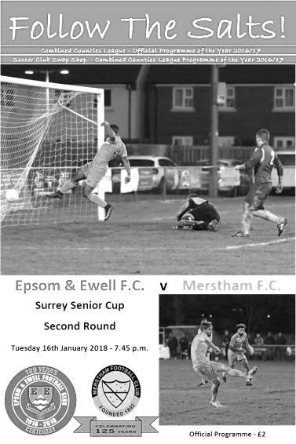
Way back in 1965 Epsom & Ewell and Merstham met for the very first time, with our club coming away from the tiny Surrey Senior League venue, then based at Albury Road, with a comfortable 5-0 victory. Fast forward 52 years and with that League now known as the Combined Counties League, the positions were completely reversed as an impressive Merstham side eased to a comfortable victory at High Road.

This is not an indication of how Epsom have fallen as a club, particularly over the last thirty years, it is more an acknowledgement of Merstham's success over that time. It's ten years now since they dominated our League and moved up to the Isthmian League, but their success continues unabated and in a competition that they have claimed three times in the last ten years, they were not going to take chances with an Epsom side under the Management of Neil Grant for the first time and did us the honour of fielding a very strong team.

With Ashley Thompson injured, Rob Hendry ill, Alistair Turpie unavailable and Marlon Pinder and Endrit Dobraj cup tied, Kane Grandison, Ben Dyson, Liam Roberts, Conor Young and Reisse Griffin came into the starting eleven following our win at Godalming Town three days previously and we kicked off in front of a disappointing crowd of just 86, although admittedly it was a bitter evening.

It's a very positive sign that we competed with them as equals for the first twenty five minutes of the match. Our skipper Alex McKay, nearing the 200 appearance mark for the club, was in action early, intercepting a dangerous ball in just in front of Conor Young, but in the 10th minute we were unfortunate not to take the lead ourselves as Kyen Nicholas held the ball up and teed up Lloyd Connelly, whose curling effort from 20 yards just clipped the bar of Chris Haigh's goal.

One of the key battles of the night came on the Merstham right flank where their flying winger Alex Addai and our own Reisse Griffin had a terrific battle throughout, despite our man being better suited to our right hand side. Inevitably though, the Isthmian League Premier Division outfit began to take charge of matters and in the 26th minute their first real shot in anger was deflected wide for a corner, from which a header was

planted onto the roof of our net. Three minutes later though they were ahead as their right winger finally managed to get past Griffin and his low near post cross was clipped across Young into the net by Tayshan Hayden-Smith.

Young was in action soon after this as a left wing cross was met by an unmarked header, but was able to tip it over the bar. Unfortunately in the 36th minute we conceded again as a left wing cross was deflected into the path of the incoming Sean Bonnett-Johnson who finished clinically from close range. In truth the visitors had further chances as the half came to the close with Young making some more saves, but in first half injury time Ben Dyson made space on the left and sent a perfect cross into the box but our young defender Noah Stew-Lewis maybe didn't realise how much time he had and ducked into the header a little, sending it over the bar from 12 yards out.

The second half continued to take a similar pattern with Merstham doing the majority of the pressing. Despite our decision to keep quite a high line to compress their midfield, we were still treated to a passing masterclass which only highlighted the standard between the two steps of football nowadays. It was one of those days where you wished you could have met them on a ploughed field, instead of the excellent Chipstead surface. They thought they had scored in the 62nd minute when a deep cross from the left was finished off from close range by Addai, although it was disallowed by a late flag. It seemed a bit late for an offside call though and it actually transpired that Addai had used his hand, for which he received a yellow card.

We made a couple of substitutions as Adam Heagney limped off and Nicholas was withdrawn with an eye on Saturday's important League match with Balham and Scott Murphy was on target with a low drive from twenty yards, but after half an hour of good work, we then conceded three times in the final thirteen minutes to leave a slightly harsh scoreline as we tired. The third goal after 77 minutes came with a fairly straight pass through our defence where Tom Collins just got his toe to the ball ahead of the advancing Young, leaving him an empty net. Four minutes later Addai turned provider again with a strong run and cut back for substitute Alberto Lubango to knock in from close range, and six minutes later Lubango scored the goal of the night with a curling effort into the far corner from around 20 yards.

It was an unfortunate ending, but there were many positives to take from this match against a team that will quite probably be favourites to win this competition again. We never gave up, competed throughout and as our new Manager confirmed to me after the match, there are still more players expected to join the ranks with 26 attending training last Thursday. The present might be a bit disheartening if you look at the League table right now, but the future appears bright.

Epsom and Ewell: Conor Young, Noah Stew-Lewis, Reisse Griffin, Adam Heagney,
Alex McKay (c), Kane Grandison, Liam Roberts, Scott Murphy, Kyen Nicholas,
Ben Dyson, Lloyd Connelly

Subs: Samuel Marks for Heagney (63) Germaine Jeannoel for Nicholas (65)

First Eleven Appearances 2017/18 - (max 33)
Name | Debut | 2017/18 |  |  |  | Career Totals
 |  | App | Sub | Total | Goals | App | Sub | Total | Goals
AJAYI Tayo | 06/08/2017 | 21 | 0 | 21 | 1 | 94 | 13 | 107 | 7
BROOKS Jordan* | 06/08/2017 | 1 | 1 | 2 | 0 | 1 | 1 | 2 | 0
BURROWES Joshua* | 02/12/2017 | 9 | 0 | 9 | 0 | 34 | 0 | 34 | 0
CASTELL Cristian* | 06/08/2017 | 9 | 1 | 10 | 0 | 258 | 14 | 272 | 6
CONNELLY Lloyd | 14/10/2017 | 5 | 1 | 6 | 0 | 248 | 29 | 277 | 18
DEWAR Ali | 29/10/2011 | 18 | 2 | 20 | 0 | 55 | 11 | 66 | 1
DOBRAJ Endrit | 18/11/2017 | 16 | 1 | 17 | 5 | 84 | 23 | 107 | 28
DYSON Ben | 12/08/2017 | 10 | 2 | 12 | 6 | 343 | 21 | 364 | 207
FRANKLIN Ben | 03/03/2015 | 0 | 1 | 1 | 0 | 0 | 1 | 1 | 0
GRAHAM Bentley | 09/02/2016 | 2 | 4 | 6 | 1 | 2 | 4 | 6 | 1
GRANDISON Kane | 11/11/2017 | 2 | 1 | 3 | 0 | 2 | 1 | 3 | 0
GRIFFIN Reisse | 08/08/2015 | 3 | 0 | 3 | 0 | 3 | 0 | 3 | 0
HARLAND-GODDARD Tom* | 06/08/2017 | 10 | 3 | 13 | 2 | 10 | 3 | 13 | 2
HARRIS Colin* | 04/08/2012 | 1 | 2 | 3 | 0 | 1 | 2 | 3 | 0
HATFIELD Jamie | 11/11/2006 | 17 | 2 | 19 | 0 | 286 | 51 | 337 | 86
HAYWARD Ben | 07/03/2007 | 2 | 2 | 4 | 0 | 2 | 2 | 4 | 0
HEAGNEY Adam | 16/08/2016 | 19 | 1 | 20 | 1 | 150 | 38 | 188 | 13
HENDRY Rob | 08/08/2015 | 3 | 0 | 3 | 0 | 3 | 0 | 3 | 0
HOUGH Kyle | 14/08/2007 | 0 | 2 | 2 | 0 | 0 | 2 | 2 | 0
JASPER Joe* | 11/11/2017 | 2 | 0 | 2 | 0 | 70 | 7 | 77 | 3
JEANNOEL Germaine | 02/12/2017 | 20 | 0 | 20 | 0 | 32 | 2 | 34 | 1
KENNEDY Calum | 18/11/2017 | 1 | 0 | 1 | 0 | 76 | 33 | 109 | 9
LAW Franky* | 06/08/2017 | 4 | 0 | 4 | 2 | 4 | 0 | 4 | 2
LOFTUS-CHEEK Joe | 06/08/2017 | 9 | 4 | 13 | 2 | 26 | 20 | 46 | 3
MARKS Samuel | 06/01/2018 | 1 | 3 | 4 | 0 | 1 | 3 | 4 | 0
MARVELL Dale* | 15/01/2000 | 2 | 0 | 2 | 1 | 2 | 0 | 2 | 1
MASTERSON Shaun | 25/11/2017 | 17 | 8 | 25 | 4 | 17 | 8 | 25 | 4
MCKAY Alex | 20/12/2008 | 5 | 0 | 5 | 0 | 66 | 6 | 72 | 14
MOHAMMED Mohammed* | 23/12/2017 | 14 | 2 | 16 | 1 | 16 | 7 | 23 | 1
MULLINGS Corey | 23/12/2017 | 1 | 0 | 1 | 0 | 1 | 0 | 1 | 0
MURPHY George | 19/03/2013 | 2 | 0 | 2 | 0 | 2 | 0 | 2 | 0
MURPHY Scott | 20/01/2007 | 7 | 3 | 10 | 0 | 7 | 3 | 10 | 0
MYERS Antony | 23/12/2006 | 4 | 1 | 5 | 0 | 4 | 1 | 5 | 0
NICHOLAS Kyen | 13/01/2018 | 23 | 1 | 24 | 3 | 23 | 1 | 24 | 3
NWACHUKWU Jason* | 01/10/2016 | 2 | 2 | 4 | 0 | 2 | 2 | 4 | 0
O'BRIEN Louis* | 28/08/2017 | 1 | 0 | 1 | 0 | 12 | 1 | 13 | 0
PINDER Marlon | 13/01/2018 | 14 | 7 | 21 | 2 | 20 | 20 | 40 | 5
ROBERTS Liam | 12/08/2017 | 18 | 0 | 18 | 0 | 19 | 0 | 19 | 0
ROBINSON Sam* | 22/10/2011 | 21 | 0 | 21 | 1 | 94 | 13 | 107 | 7
ROSE Daniel* | 25/10/2016 | 1 | 1 | 2 | 0 | 1 | 1 | 2 | 0
SELLICK Rory | 27/01/2018 | 9 | 0 | 9 | 0 | 34 | 0 | 34 | 0
SMITH Andy* | 25/08/2017 | 9 | 1 | 10 | 0 | 258 | 14 | 272 | 6
SMITH Taryn | 28/10/2017 | 5 | 1 | 6 | 0 | 248 | 29 | 277 | 18
STEW-LEWIS Noah | 09/12/2017 | 18 | 2 | 20 | 0 | 55 | 11 | 66 | 1
THOMPSON Ashley | 21/08/2017 | 16 | 1 | 17 | 5 | 84 | 23 | 107 | 28
THOMSON David* | 02/09/2017 | 10 | 2 | 12 | 6 | 343 | 21 | 364 | 207
TURPIE Ali | 31/03/2016 | 0 | 1 | 1 | 0 | 0 | 1 | 1 | 0
WHITE Sean | 02/08/2014 | 2 | 4 | 6 | 1 | 2 | 4 | 6 | 1
YOUNG Conor | 07/03/2015 | 2 | 1 | 3 | 0 | 2 | 1 | 3 | 0
* Player has left the club

Combined Counties League Premier Division
Opponents All-time Records
inc Saturday  27th January | P | W | D | L | F | A | PPG | GD | Best  Win | Worst  Loss
Sutton Common Rovers* | 14 | 9 | 3 | 2 | 30 | 19 | 2.14 | +11 | 4-0 | 0-5
Horley Town | 32 | 21 | 5 | 6 | 71 | 37 | 2.13 | +34 | 6-0 | 1-3
Banstead Athletic | 38 | 23 | 7 | 8 | 62 | 38 | 2.00 | +24 | 5-0 | 0-4
Spelthorne Sports* | 9 | 5 | 3 | 1 | 16 | 11 | 2.00 | +5 | 6-2 | 1-5
Abbey Rangers | 5 | 3 | 1 | 1 | 12 | 5 | 2.00 | +7 | 7-1 | 2-3
Godalming Town | 3 | 2 | 0 | 1 | 4 | 5 | 2.00 | -1 | 2-1 | 0-3
Bedfont Sports | 12 | 7 | 2 | 3 | 21 | 19 | 1.92 | +2 | 5-1 | 0-7
Colliers Wood United | 24 | 14 | 2 | 8 | 47 | 39 | 1.83 | +8 | 4-0 | 0-5
Farnham Town | 17 | 9 | 4 | 4 | 30 | 25 | 1.82 | +5 | 3-0 | 1-4
Guildford City | 19 | 11 | 1 | 7 | 36 | 25 | 1.79 | +11 | 5-1 | 1-5
Knaphill | 9 | 5 | 1 | 3 | 19 | 15 | 1.78 | +4 | 4-0 | 2-6
Westfield | 22 | 12 | 3 | 7 | 43 | 41 | 1.77 | +2 | 6-1 | 0-5
Walton & Hersham | 53 | 25 | 11 | 17 | 105 | 101 | 1.62 | +4 | 8-0 | 1-9
Hanworth Villa | 18 | 8 | 5 | 5 | 39 | 28 | 1.61 | +11 | 5-0 | 1-4
Camberley Town** | 91 | 38 | 23 | 29 | 159 | 126 | 1.52 | +33 | 9-1 | 0-4
Redhill | 35 | 14 | 2 | 19 | 63 | 77 | 1.26 | -14 | 7-2 | 2-8
Chertsey Town | 51 | 19 | 5 | 27 | 77 | 95 | 1.22 | -18 | 3-0 | 0-7
North Greenford United | 13 | 4 | 2 | 7 | 19 | 24 | 1.08 | -5 | 3-0 | 1-4
AFC Hayes | 11 | 2 | 3 | 6 | 18 | 20 | 0.82 | -2 | 7-0 | 0-3
CB Hounslow United | 4 | 1 | 0 | 3 | 6 | 11 | 0.75 | -5 | 2-0 | 1-5
Balham | 1 | 0 | 0 | 1 | 0 | 4 | 0.00 | -4 | x | 0-4
* includes one loss on penalties v Spelthorne and one win on penalties v Sutton Common Rovers
** includes one abandoned match v Camberley

Club Records - 3rd February
Date | Day | Competition |  | Opponents |  | Scorers
03/02/34 | Sat | London League | A | Streatham Town | 1-0 | T.Dunne
03/02/51 | Sat | Corinthian League | H | Worthing | 10-0 | L.Keen (3), E.Watkins (3), S.Faggetter (2), B.Musto (2)
03/02/62 | Sat | Corinthian League | H | Horsham | 4-5 | R.Francis, L.Pritchard, T.Millard, R.Dowse
03/02/68 | Sat | Athenian League 2 | H | Uxbridge | 1-2 | J.Eales
03/02/73 | Sat | Athenian League 2 | A | Wingate | 2-1 | D.Rainham (pen), A.Webb
03/02/74 | Sun | Southern  Combination Cup 2 | H | Egham Town | 0-5
03/02/75 | Mon | F.A. Vase 4 | A | Eastbourne Town | 2-0 | T.Lee, T.Tuite
03/02/79 | Sat | Isthmian League 1 | A | Walton & Hersham | 4-2 | T.Tuite (2), G.Archer (2)
03/02/87 | Tue | Isthmian League 1 | A | Lewes | 0-2
03/02/96 | Sat | Isthmian League 3 | H | Aveley | 2-2 | S.Miller, o.g.
03/02/98 | Tue | Isthmian League 3 | H | Flackwell Heath | 1-0 | A.Boxall
03/02/04 | Tue | Isthmian League 1s | H | Corinthian Casuals | 4-1 | C.Watkins (2), S.Hatton (2)
03/02/07 | Sat | Combined Counties  Premier Division | H | Bookham | 1-1 | A.Myers
Historical Decades
90 years ago – Epsom Town F.C.
04/02/28 | Sat | Friendly | A | Sutton United | 1-1 | R.Marlow
80 years ago – Epsom F.C.
05/02/38 | Sat | London League Cup 1  2nd replay | H | Tilbury | 8-1 | T.Rochester (3), J.Jones (3), B.Beglan, G.Collins
70 years ago – Epsom F.C.
07/02/48 | Sat | London League | A | Chelmsford City Reserves | 0-14
60 years ago – Epsom F.C.
01/02/58 | Sat | Corinthian League | A | Wembley | 2-3 | J.Bangs (2)
50 years ago – Epsom & Ewell F.C.
03/02/68 | Sat | Athenian League 2 | H | Uxbridge | 1-2 | J.Eales
40 years ago – Epsom & Ewell F.C.
04/02/78 | Sat | Isthmian League 2 | H | Tring Town | 0-3
30 years ago – Epsom & Ewell F.C.
13/02/88 | Sat | Isthmian League 2s | H | Maidenhead United | 2-0 | C.Holding, S.Flack
20 years ago – Epsom & Ewell F.C.
03/02/98 | Tue | Isthmian League 3 | H | Flackwell Heath | 1-0 | A.Boxall
10 years ago – Epsom & Ewell F.C.
02/02/08 | Sat | Combined Counties  Premier Division | A | Raynes Park Vale | 2-2 | C.Heuston (2)

History Corner – 3rd February
80 years ago this week we welcomed Tilbury to West Street for a second replay of a London League Cup First Round tie. The two clubs had met twice previously, drawing 1-1 at West Street on the opening day of the season, and then 3-3 at the Orient Field, which was their ground at the time, as they didn’t move to their present venue across the road until just after the war. This was expected to be a tight match but we ran away with it 8-1. Both Tommy Rochester and Jimmy Jones scored hat tricks this day but with this match having taken so long to resolve, the League made the decision to hold the competition over into 1938/39 instead, when we would eventually reach the Final, almost 20 months after we played the first match!

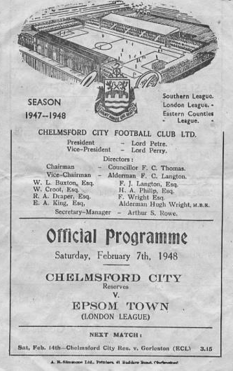
70 years ago this week we suffered our worst ever defeat in club history, being royally stuffed 14-0 at New Writtle Street, home of Chelmsford City Reserves in a London League match in front of 2,789 spectators. Len Galley scored seven goals and Denny Foreman got five while we ended up with ten men through injury. Not a good day at the office! (see programme pictured)

67 years ago today we defeated Worthing 10-0 in a Corinthian League match at West Street. They weren’t a great team at the time, but we had lost our previous five matches ourselves, so weren’t anything special. It just all went right on the day. Les Keen and Ernie Watkins both scored hat tricks and for Ernie it was to be the only time he would score three in over 400 appearances from 1945-60. Typically, we lost the return league fixture 2-1 just four weeks later!

43 years ago today we finally played our much delayed F.A. Vase tie against Eastbourne Town. It had been postponed many times and eventually had to be played at Princes Park, home of Eastbourne United, which had floodlights. We won 2-0 with goals from Trevor Lee and Tommy Tuite, while five days later a Phil Walker goal would see us past Hornchurch in the last 16 and into the Quarter Final.

22 years ago today we had a home match against Aveley, played at Maidenhead United’s York Road ground as Banstead was double booked. We led 2-0 only to draw 2-2 but that’s not what this game would be remembered for. With around an hour gone, we were a goal up and sent a harmless ball in from the right wing. The defender called loudly for it, but to the chorus of “away, away” he promptly lashed the ball as hard as he could; slicing it straight past the keeper from ten yards and into the bottom corner of his own net. Even the keeper was laughing. Ok, he wasn’t, but he could probably laugh about it afterwards! It remains the best own goal I’ve ever seen!

14 years ago today our club record run of thirty matches without a win finally ended at home to Corinthian Casuals, the team we had last beaten in our opening away fixture back in August. We conceded early, but on a very windy evening at Merland Rise we fought back to equalise by half time and ran away with it in the second half by four goals to one, with Simon Hatton and a young Craig Watkins scoring twice. We still went down though, just one point below the Casuals!

Buildbase F.A. Vase
Fifth Round – 3rd February
Wolverhampton SC | V | Leighton Town
Thatcham Town | V | Bromsgrove Sporting
Marske United | V | Bradford Town
Coleshill Town | V | Bracknell Town
1874 Northwich | V | Chichester City
Stockton Town | V | Stourport Swifts
Windsor | V | Hamble Club
Melksham Town | V | Tring Athletic

EL Records Premier Challenge Cup
Quarter-Finals
Godalming Town | 6/2 | Knaphill
Spelthorne Sports | 6/2 | Walton & Hersham
Sutton Common Rovers | 2-1 | Cobham
Worcester Park | 3/2 | Colliers Wood United

Surrey Senior Cup
Second Round
Leatherhead | V | Kingstonian
Epsom & Ewell | 0-5 | Merstham
Farnham Town | 0-3 | Met Police
Westfield | 2-3 | Colliers Wood United
Spelthorne Sports | 0-4 | South Park
Sutton United | 7-1 | Molesey
Chipstead | 3-2 | Tooting & Mitcham United
Dorking Wanderers | 2-1 | Carshalton Athletic
Quarter Finals
Met Police | 15/2 | Leatherhead / Kingstonian
Colliers Wood United | 21/2 | Dorking Wanderers
Sutton United | 13/2 | Merstham
Chipstead | 13/2 | South Park

Sutton Common Rovers F.C. – History
Chairman and Life President Alan Salmon founded SCR F.C in 1978, when the club began life as INRAD FC, based in Carshalton. The club entered a new era when Alan moved to Sutton and arranged sponsorship with his new neighbour, CENTRE 21 FC was born. This era saw the club running one Saturday side, three Sunday sides and three Youth sides. Centre 21's sponsorship continued until the club's youth players were no longer under 21 years old.

The club again sought a new identity; SUTTON COMMON ROAD FC was formed and subsequently abbreviated to SCR FC. Since then the club has had five major sponsors whose names have been incorporated into the clubs affiliated name: SCR PLOUGH (twice), SCR GRAPES, next the club's longest sponsor SCR LITTEN TREE (7 years) & finally SCR Kingfisher, Ewell with whom we started our venture in Saturday football in 2004/05.

It was at this point that the club took the decision to revert back to using the SCR name alone, feeling that as we strive for continued promotion we needed to disassociate ourselves with the whole ‘pub team’ image. The club however did take sponsorship from the Fox & Hounds, Carshalton for the Saturday first team in 2006/07, but the decision was made that the pub name would not be incorporated into our own, for the above reason.

The club entered yet another new era this season, with the introduction of a third Saturday side and the first team moving to the Middlesex County FL (and a name change SUTTON COMMON ROVERS) in the pursuit of Combined Counties football, having failed with an application from the Surrey South Eastern Combination at the end of season 2006/07 having finished joint top (3rd on goal difference… -1 goal)

A third place finish in the Middlesex County League Premier Division in 2007/08 meant that our promotion to the CCL was not assured but months of hard work & determination from the management team SCR eventually secured a place for the clubs first time in their 30 year history at the league AGM in June 2008 and the reserves joined the CCL Reserve Division under the guidance of Alex Avis & Justin Salmon.

Season 2008/09 saw the latest name change of the club, the inclusion of “MOLE VALLEY” to form our current name, MOLE VALLEY SCR FC reflecting the area in which we played after migrating from the London Borough of Sutton. Season 2009/10 saw the club reach a Surrey Cup final, narrowly being defeated by Sutton United on penalties after a 1-1 extra time draw and in the same season compete in the F.A. Vase for the first time in our relatively short history.

We finished Champions of Division One (playing out of Cobham FC after we lost our ground two weeks before the start of the season) at the second time of asking, narrowly pipping Worcester Park to the post in a fine run which saw us finish three points clear on the final match of the season, assuming as we believed, that we were awarded the points from the postponed Coulsdon match who unfortunately were unable to field a side for our scheduled league game some weeks earlier.

The following season saw the club play at our highest level to date, and make our F.A. Cup debut, although this lasted just one game and ended in a 5-0 defeat against Chertsey Town. The club managed two seasons in the Premier Division, before being relegated back to Division 1, following a start to the season that contained 12 straight league defeats.

The 2012/13 season started with a rebuilt side and expectations of consolidation, however a 20 game unbeaten run propelled us into runners up spot, and a much coveted promotion back to the Premier Division. 2013/14 started brightly, but went to the last game, and a point earned survival. It was the same last season, and although we lost to Guildford City, we still managed to survive.

In 2015/16 the club changed its name back to Sutton Common Rovers, and after much hard work by The Salmons, a return to Sutton to ground share with Sutton United was arranged. The club reached the Fourth Round of the F.A. Vase before defeat at eventual semi-finalists Bowers & Pitsea. A run of five league defeats from January to April left the club threatened with relegation but managed to finish 19th and ensure another season in the Combined Counties Premier Division, while in season 2016/17 the club finished 12th, a four year high, and a trophy with the Southern Combination Challenge Cup secured after a 4-1 win over Camberley Town.

Centre page for results

Centre page for results

Every Opponent A-Z
Over the years we have played many, many different opponents. Exactly how many is a difficult question, as it all depends on your definition. Are Camberley & Yorktown different to Camberley Town, or are Epsom Town different to Epsom F.C. or Epsom & Ewell F.C.?

In my analysis I have classed them as the same team, and will work through them all from A to Z. Some we have played many times, whilst others we have met maybe just once or twice. Enjoy!

Wingate: Played 16 - W5 D5 L6 - F27 A32 - PPG - 1.25 - Below Average

The story of Wingate FC is a very complicated one. Founded in 1946 they were named after Orde Wingate, a British Army Officer who was famous for creation of the Chindit deep-penetration missions in Japanese held Burma during World War Two; a war he unfortunately failed to survive after being killed in an Aircraft accident in 1944. They were a Jewish club playing at Hall Lane in Hendon and they made their way through the Middlesex Senior, Parthenon and then the London League for ten years before joining the Delphian League in 1962. When that merged with the Corinthian and Athenian Leagues in 1963 we were placed a division above them, but relegation in 1965 threw the teams together, where we would remain for eight seasons.

Our first meeting came on Saturday 5th March 1966 at West Street and we trailed at the half but recovered to win 4-1 with two goals from Peter Scott, one from Alan Cox and the other from future England Amateur International Peter Deadman and on our first visit we secured a 1-1 draw.

The following season we nearly didn’t meet as our club had been under a warning for its disciplinary record and on 9th December 1966 the Surrey F.A. suspended us indefinitely! This took effect from the following Monday but by that Friday, Chairman George Tarran had attended an appeal and we were reinstated. The following day we went to Wingate and led 2-1 at the half, extending this into a bizarre 7-5 victory. We have only had one other first team match since then with 12 goals and bearing in mind our issues at the time, the local Press described this match as a team of rabbis (Wingate) against a team of vicars, such was the cleanliness of the match!

Unfortunately we let a 2-1 lead turn into a 2-3 defeat at home in the February return, although we registered an away draw and a 3-1 home win with a Johnny Eales hat trick the following season.

From that point onwards though, results took a turn for the worse. Obviously we were not a good team around this time but from 1968/69 we would register just three draws from the next eight matches, including a 0-5 away defeat and a 1-5 home loss in our ill-fated 1970/71 season.

At least in our final Athenian League season of 1972/73 we were able to secure our first League double over them with 2-1 and 3-1 wins, but we still finished second from bottom of the League albeit ahead of Wingate! Despite this, it was our club that were rejected by the League and we went to the Surrey Senior League where it all started to happen again for us.

However, all was not well at Wingate either. The 1972/73 season had been played at a number of venues as Hall Lane had been requisitioned by the Ministry of Transport and it now sits under the M1 Motorway, approximately one and a half miles north of Junction 1! Our League match that season took place at Brickfield Lane in nearby Arkley and their very future was under threat.

Wingate found salvation at Summers Lane, home of Finchley, where they remained until 1975 when they merged with the famous old Leyton club and became Leyton Wingate for a while, playing out of the Hare and Hounds ground in Lea Bridge Road.

We met the Leyton Wingate club on a couple of occasions during 1975/76 and again in1986/87, but I’ve covered these matches earlier. This is where it gets really confusing though as many at the club were not happy with the merger and re-constituted the old club name in 1984.

We defeated them in a London Challenge Cup tie in 1991 at West Street and the old Leyton Wingate name continued until 1992 when Wingate was removed from the name and they became Leyton once again before further name changes resulted in them becoming Waltham Forest. A new Leyton club followed in 1997 and reclaimed the original name, but then folded suddenly in January 2011 under a bit of a cloud (VAT fraud) and the second oldest club name in London was wiped from the list.

Wingate though, had better luck. The newly reformed club threw in their lot back at Summers Lane, which was refurbished and renamed the Harry Abrahams Stadium. Nowadays known as Wingate & Finchley they hold their place in the Isthmian League Premier Division currently, although it took them a while to get there and on their way up the leagues we met for seven seasons until our promotion in 2002. Considered as a continuation of the Finchley club, I included their results together many years ago when I was covering clubs beginning with F, although I can always make room for their wonderful Art Deco 1930 vintage stand (below). A lesser known stand was that at Hall Lane which disappeared in 1972 and that is shown lower down here.

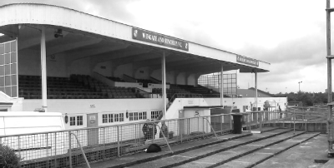

From behind the goal
Epsom & Ewell 1-1 Abbey Rangers
Combined Counties League - Premier Division - Tuesday 23rd January 2018

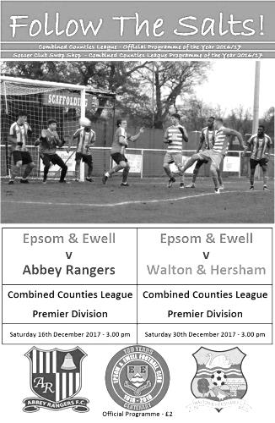
Hard earned point secured but could it have been more?

Salts supporters and Management will have been quietly pleased with this hard working performance against Abbey Rangers on Tuesday evening at High Road but will have been well aware that the match could have been put to bed long before the visitors replied with a deserved equaliser.

If you exclude the cup tie against Merstham, we made three changes from our important League win at Godalming Town. Conor Young returned in goal, while Liam Roberts replaced Lloyd Connelly and Reisse Griffin took the place of Noah Stew-Lewis in the starting eleven. On a surprisingly warm evening at Chipstead both sides contributed to an entertaining match for the neutral.

Of course, it's difficult to remain neutral when your team faces an uphill battle against relegation, and it could not be disguised that this was a massively important match for our club. To get out of trouble, you have to beat the teams in the bottom half and our visitors, sitting in fourteenth place were most definitely one of those. Of course, they will have had other ideas and probably looked at a match against the team at the foot of the table as an opportunity to spring into the top ten.

As a result, the match started at quite a frenetic pace, although it was clear that these were two evenly matched teams and the opening exchanges bore this out, before the game was halted for a few minutes following an injury to Ben Kersley, who was able to continue after treatment.

In the 13th minute we created the first real chance in the match. Marlon Pinder produced a good run and as he drew men towards him, released Endrit Dobraj on the right wing overlap. His cross took a slight deflection, so by the time it reached Kyen Nicholas eight yards out it was slightly behind him, and although he managed to get the shot on target, it lacked power and Liam Stone in the visitors goal was able to palm the ball away from danger.

Abbey responded with a long range effort that was deflected for a corner and then a right wing cross came in to Kersley in space, but the ball in was a little high and although he chested the ball well, he was unable to control the subsequent volley which went wide of Young's goal.

We went ahead in the 30th minute. Pinder made another good run towards goal and released the ball to Nicholas just as he was clattered into. However, the advantage was played and Nicholas, recently of Abbey Rangers; in fact, so recently that he was listed in the visiting line up for the original match in December, produced a stunning low strike across Stone from the edge of the box, with the ball going into the net of the keeper's left hand post.

He could and maybe should have made it 2-0 three minutes later after Rob Hendry on the left set up Roberts who delivered the ball in low, but our man smashed it powerfully at goal but the ball was well blocked by Stone, who may not have known too much about it, but deserved credit for coming out quickly and he received his reward when the loose ball bounced off a defender and back for him to fall on!

A Dobraj free kick buzzed through the Abbey six yard box and out the other side, while a Hendry delivery from the left cannoned kindly off Joe Macklin for Stone to retrieve. Then Roberts sent a dangerous ball in that was inches in front of both Nicholas and Pinder before Nicholas had a final chance in injury time when a left wing cross was only headed out to Alex McKay and his shot in was controlled, but as our man turned to shoot he lost his balance and sliced the ball harmlessly wide from eight yards. He was clearly keen to make some sort of impact against his own club, and the irony here was that he might have had three goals by the half, yet had actually taken the hardest chance of the three!

We had been well on top following the goal and were well worth our lead, but could we keep it going in the second half? The answer ultimately was no as the visitors pushed for an equaliser they would eventually secure. Nicholas should have hit the target when he headed over a pinpoint Hendry cross on the hour, but Young was much busier and we threatened only sporadically in the second half. As the game went on, many fouls were being overlooked by the referee in the pursuit of playing the advantage, which was a good plan, in theory. However, a foul is a foul and when players began to realise that they weren't going to be penalised the game moved from being feisty and competitive to becoming a little bit naughty!

This manifested itself in the 64th minute when a late challenge from a visiting player caused Dobraj to retaliate by kicking out at the opponent, followed by the inevitable scuffle that always seems to happen when these two teams meet up. I felt certain that our man would become our first sending off of the season. Indeed our Manager Neil Grant also felt that way as he shouted that we would revert to a 4-4-1 formation! However, the referee gave both players a lecture and a yellow card each, which did nothing to restore anyone's confidence in the decision making. Indeed, people were beginning to question whether he had actually been playing advantage and whether he just failed to recognise the challenges as fouls in the first place!

Whether we lost our concentration at that point is hard to say, but within a minute of the restart Abbey were level. The clock was showing the 69th minute when Michael Hill's left wing cross came in. We reached the ball first, but our clearing header appeared to hit a team mate and fell kindly for substitute Alex Hendrie to finish from close range. It had been coming though and only a superb saving tackle from Griffin a minute later prevented them from taking the lead.

In response Pinder made another great run in the 77th minute before releasing Roberts in a really good position, but he took a little too long to set himself and Stone was out to block his shot quickly and it nearly cost us as a thirty yard shot from Hill rested on the roof of our net. There was still time for a little more controversy as Adam Heagney was hit very late and although the referee screamed the advantage at that point, he never even had a word with the offender afterwards, although of course still found time to book McKay apparently for taking him to task over his lack of action. The final threat came in injury time with a great run from substitute Ben Dyson, but as he closed in on goal from an angle Bradley Thomas made a great saving challenge to clear the danger, and our subsequent corner came to nothing.

Overall if you looked at the 90 minutes as a whole, which we must, then a draw was a fair result. However, this match contained a bit of the "what if" element as you felt that a second or even a third goal at the right time would have presented the visitors with a mountain that was too high to climb. It wasn't to be this time.

Epsom and Ewell: Conor Young, Endrit Dobraj, Reisse Griffin, Adam Heagney, Alex McKay (c), Ashley Thompson, Liam Roberts, Scott Murphy, Kyen Nicholas, Marlon Pinder, Rob Hendry

Subs: Taryn Smith for Thompson (70), Ben Dyson for Hendry (78), Lloyd Connelly for Roberts (82)

Sponsors Player of the Match: Conor Young

From behind the goal
Spelthorne Sports 0-0 Epsom & Ewell
Combined Counties League - Premier Division - Saturday 27th January 2018

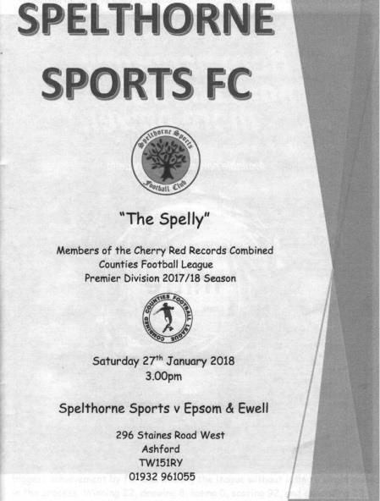
Hard earned point in horrible conditions makes it three matches unbeaten

On a miserable, wet and windy afternoon at the Spelthorne Sports Club our boys were good value for the point they earned and with a bit of luck it would have been all three.

Reliability is key to building a good team and Neil Grant only made two changes this week with Lloyd Connelly and new player Rory Sellick coming in for the absent Marlon Pinder and Rob Hendry. More significantly though, for the first time all season we had an unchanged back four and keeper and we rarely looked like conceding at any point. Credit should also be given to Ashley Thompson and Scott Murphy who provided excellent protection for the back four and bossed the midfield too!

We started well in horrible conditions for spectators and a deep ball was headed across goal in the fourth minute and fell nicely for new boy Sellick, but his volley of the dropping ball went just wide of Brendan Hazlett's goal. However, the home keeper would be involved soon enough and after a foul on Kyen Nicholas, Adam Heagney sent in a great free kick that Liam Roberts met with a powerful header from just five yards out but Hazlett produced a superb save from close range with the ball then rebounding out for a goal kick off the nearby Nicholas.

It wasn't until the 26th minute before Conor Young joined the action, tipping a deep cross away from an incoming striker for a corner, but the set piece was then wasted as we continued to do most of the pressing. Roberts made a good run down the right and he sent a dangerous ball across the face of goal but it

was just a fraction too hard for Connelly who had to have a try with his weaker left foot, although was unable to get his shot on target.

Still, this was a very positive half of football against a team in the top half of the table. All we needed now was to get ahead and I was sure we would be able to hold on.

The second half started badly though with Nicholas having to be replaced through injury within a minute or two of the restart. His replacement Taryn Smith put in a good try from twenty yards out but his shot was just over the bar. A Sellick header then gave Roberts a half chance just inside the area, but he seemed to be uncertain whether to chip the keeper or strike the ball firmly and in the end did neither, just lobbing the ball straight to Hazlett instead.

Roberts was replaced by Ben Dyson shortly afterwards, but it was clear to see that the game was heading towards a stalemate as the two teams began to cancel each other out. Spelthorne attacked down the right but the cross was an easy catch for Young. This sort of thing wouldn't normally make the report, but it gives a clear indication of how little was created against us during the match. They sent a dangerous ball in a couple of minutes later, following a foul by the otherwise excellent Reisse Griffin but it bounced kindly and Young was able to fall on the ball.

With ten minutes remaining, Smith set Connelly away on the left but Hazlett was out of his goal quickly to clear the ball against our man and fortuitously out for a goal kick and when the final whistle blew, a goalless draw was all we had to show for our efforts.

Still, bearing in mind that Spelthorne battered us 5-1 at High Road in September, this was an indication of how far we have come since then and while everyone accepts that there is still a long road ahead of us, we are now fully competitive with the other teams in our league and will continue to improve as the season progresses. Our opponents today can confirm that.

Epsom and Ewell: Conor Young, Endrit Dobraj, Reisse Griffin, Adam Heagney, Alex McKay (c), Ashley Thompson, Liam Roberts, Scott Murphy, Kyen Nicholas, Rory Sellick, Lloyd Connelly

Subs: Taryn Smith for Nicholas (70), Ben Dyson for Roberts (64)

Player Sponsorship
Here is the latest list for 2017/18, with new photos showing all of our players and Management that are available for sponsorship. Other new players will be added once the new photos are available.

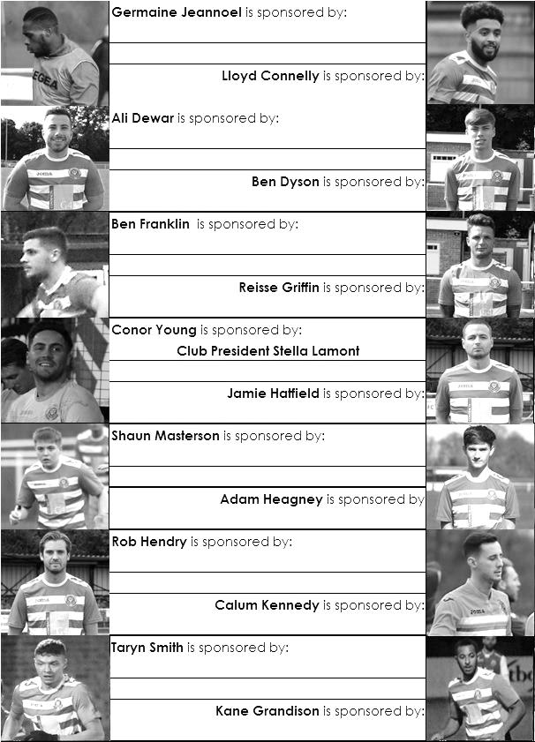

Sponsorship costs just £40 and it is easy to do. Just select a player who has not been previously sponsored and let a Committee Member know. Beware though. Until we have received the money it is possible for someone to jump in front of you, so don’t delay, sponsor today!

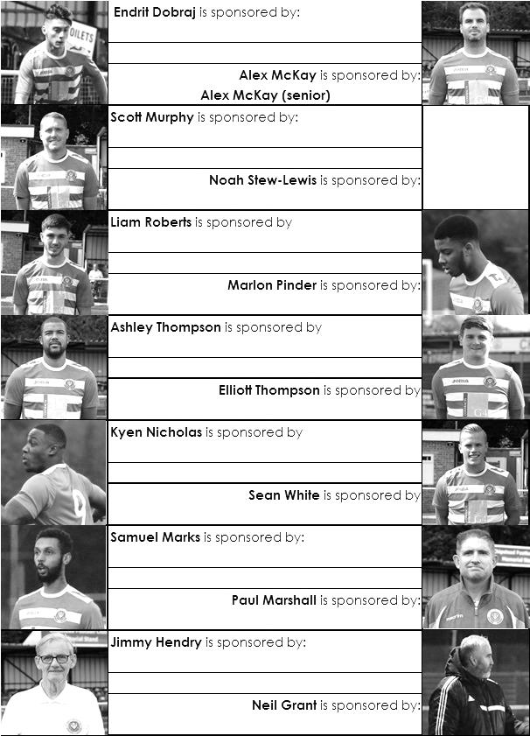

Match and Ball Sponsorships – 2017/18
Opponent | Date | Match Sponsor | Ball Sponsor
Banstead Athletic (FAC) | 06/08/17 | Club President - Stella Lamont
Chertsey Town | 15/08/17 | EEFC Management Committee
Redhill | 02/09/17 | Building Shop Ltd
Spelthorne Sports | 09/09/17 | In memory of Betty Dyke
Horley Town | 12/09/17 | Alex McKay (Senior)
Hanworth Villa | 23/09/17 | Jack Jarman
North Greenford United | 28/10/17 | Marvin and Kathy Hough
Farnham Town | 14/11/17 | In memory of Dave and Lizzie Marshall
Godalming Town | 21/11/17 | Building Shop Ltd
Guildford City | 02/12/17 | John Bonner
Walton & Hersham | 30/12/17 | Jeff and Arnold Pye
Merstham (SSC) | 16/01/18 | Paul Merritt
Abbey Rangers | 23/01/18 | Pete Beddoe’s grandchildren  George, Joseph, Ezara & Inaya
Sutton Common Rovers | 03/02/18 | David Ellins
Knaphill | 24/02/18
CB Hounslow United | 06/03/18
Camberley Town | 10/03/18
Balham | 13/03/18
Bedfont Sports | 24/03/18
Colliers Wood United | 30/03/18
Banstead Athletic | 02/04/18 | Nathan Lambert – 10 years old today!
Westfield | 14/04/18
AFC Hayes | 28/04/18 | Club President - Stella Lamont
Match sponsorship costs just £60.00!

Sponsorship includes:

Admission, programmes and hospitality for three people.

A full page advert in the programme and mascot for the day (if required).

Also, you get to choose the player of the match, who will receive a prize

If you are interested, just speak to a Committee Member,
or drop me an email at: richard.c.lambert@gmail.com

Salts Super Six Predictor
The Salts Super Six Predictor jackpot has risen to a very decent £331 for today’s match. The tickets are on sale at today’s game to the left of the gate. The matches on the ticket are to be played today!

The competition is easy to play! To win, you simply need to predict the results of six matches correctly from the three options, fill in the form and make sure it is back with our seller before the deadline on the ticket. The latest fixtures are shown below.

If you are a club regular, you just need to place your name on the sheet, although if you aren’t, then we’ll need a contact number from you too. We will announce any winners on the website within three working days, so don’t worry, we won’t miss you!

Please note that if there is more than one winner, the prize pot would be shared between the winners. All you need to do now is have a go, as many times as you like!

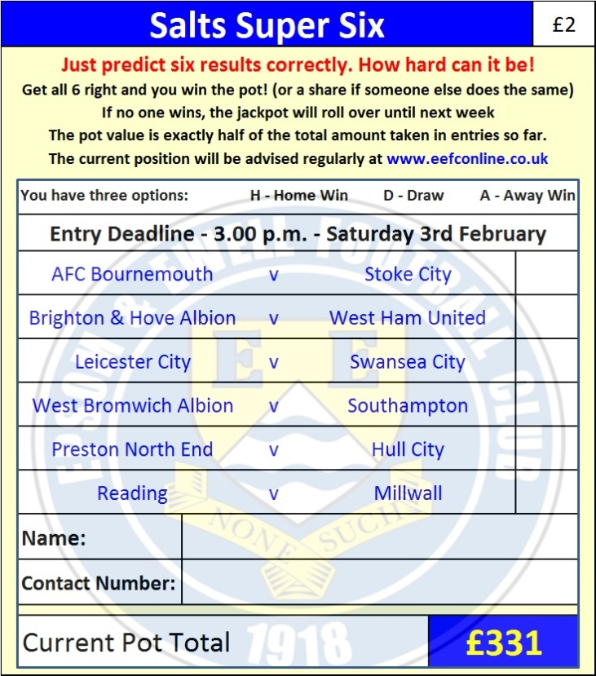

Good luck!

Combined Counties League – Premier Division
Saturday, 3rd February 2018 - Kick-off 3.00 p.m.
Epsom and Ewell  (Royal Blue & White hoops) | V |  | Sutton Common Rovers  (All Yellow – Blue Trim)
Squad | NUMBERS |  | Squad
Conor Young |  |  | Michael Eacott
Endrit Dobraj |  |  | Aaron Bogle ©
Reisse Griffin |  |  | Craig Hastings
Adam Heagney |  |  | Joe Mead
© Alex McKay |  |  | Matt Farrell
Ashley Thompson |  |  | Danny Fernandez
Marlon Pinder |  |  | Daryl Cooper-Smith
Scott Murphy |  |  | Matt Auletta
Kyen Nicholas |  |  | Asa Rixon-Nicholls
Rory Sellick |  |  | Andrew White
Lloyd Connelly |  |  | Jamil Okai
Noah Stew-Lewis |  |  | Matt Ferdinando
Ben Dyson |  |  | Tommy Smith
Liam Roberts |  |  | Matt Tanton
Taryn Smith |  |  | Craig Nelson
Rob Hendry |  |  | Marvin Roberts
Ben Franklin |  |  | Owen Davies
Shaun Masterson |  |  | Gus Lukuni
Kane Grandison |  |  | Malachi Thomas
Calum Kennedy
Troy Williams
Samuel Marks
Ali Turpie
Neil Grant | MANAGER |  | Darren Salmon
Alex McKay | ASSISTANT |  | Donny Rennalls / Marc Skinner
Jordan Clark / Jimmy Hendry | COACH / PHYSIO |  | Tony Williams/ Geoff Moxey
REFEREE: J.Oxenham
ASSISTANTS: K.Corrick, P.Jones
Today’s Match and Match Ball are kindly sponsored by:
our former Chairman David Ellins

OUR NEXT VISITORS TO HIGH ROAD
Knaphill
Cherry Red Combined Counties League – Premier Division
Saturday 24th February 2018 – 3.00 p.m.

